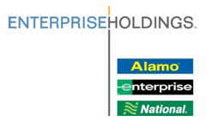
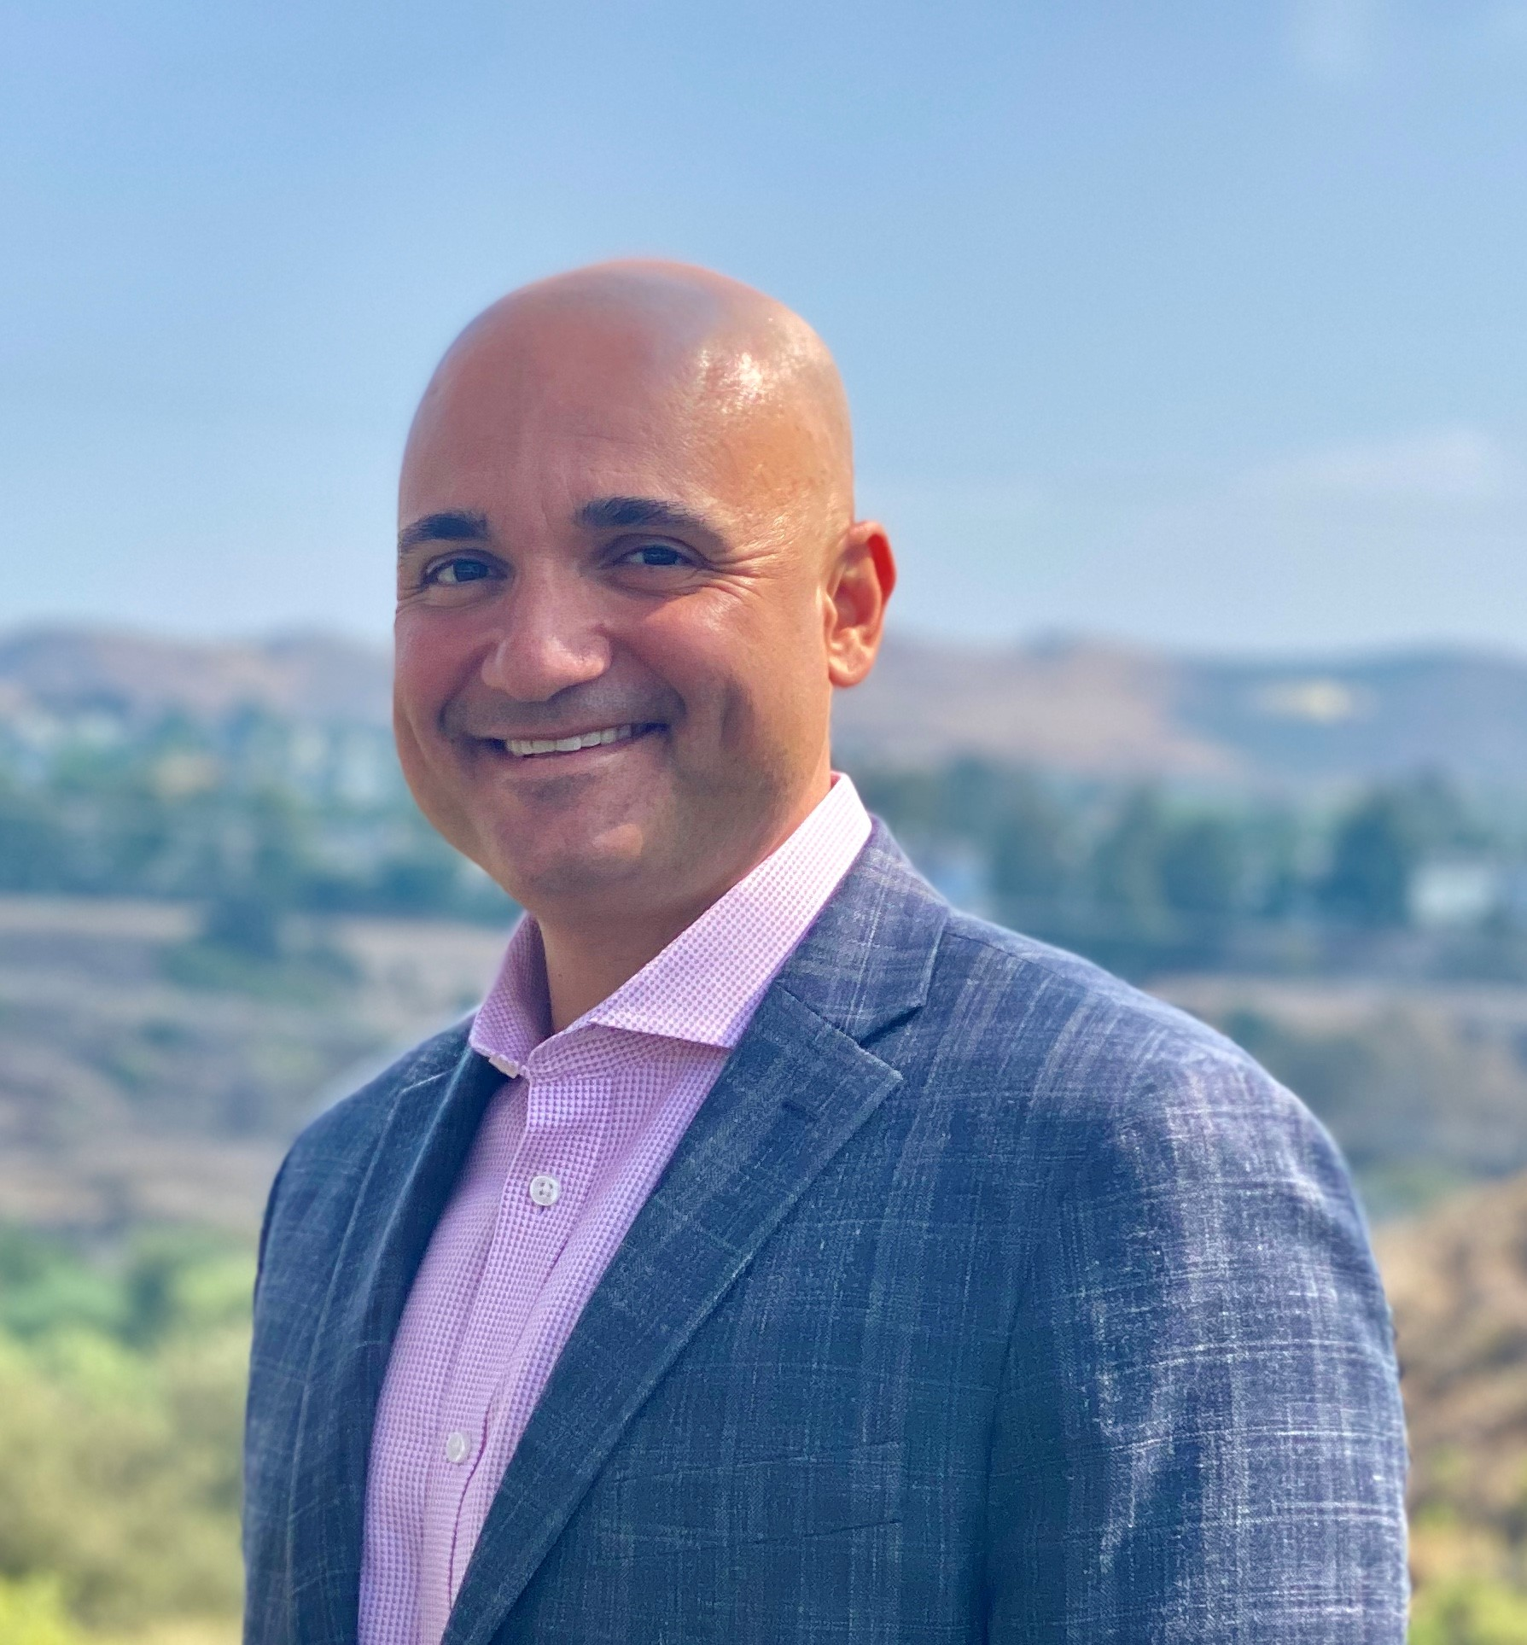

Mike Astino
Regional Sales Manager: Southern California

Hometown: Queens, NY Current City: Mission Viejo, CA
Time with Enterprise: 17 years
Career Progression:
Promoted through Enterprise Daily Rental, 8 years’ experience in operations as an Area Manager (8 stores), 6 years in sales as a Sales Manager

Primary Responsibilities: Leads team of sales professionals managing over $150M in annual sales revenue in the Southern California market. Overall book of business includes both new and existing customers. Managed travel programs help companies reduce overall travel costs while improving traveler satisfaction.

College: University of Scranton
Personal: Married, 2 Children
Hobbies: Coaching youth sports, playing piano, chess, and biking

Mike Astino
Regional Sales Manager
Southern California
201-481-9099 cell
657-221-4462 office
Michael.Astino@ehi.com
333 City Blvd. West Suite 1111
Orange, CA 92868

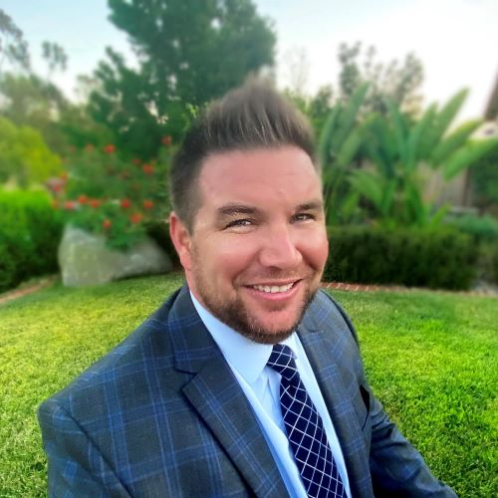

Tom Fritz
Account Executive: Southern California

Hometown: San Diego, CA Current City: San Marcos, CA
Time with Enterprise: 9 years
Career Progression:
Promoted through Enterprise Daily Rental, 5 years’ experience in operations as a Branch Manager (ran one of the largest local branches in the company), 4 years in sales creating corporate programs that utilize Enterprise Rent-A-Car, National Car Rental and Enterprise Truck Rental brands.

Primary Responsibilities: I work with corporate accounts and business travel management companies to develop and manage custom programs that focus on total cost savings, while meeting specific business rental needs with the most comprehensive service provider in the car rental industry.

College: Cal State San Marcos
Personal: Married, 1 Child
Hobbies: Golfing, surfing, biking and hiking

Tom Fritz
Account Executive
San Diego & Inland Empire
Corporate Accounts
858-663-0024 cell
858-228-4342 fax
Thomas.S.Fritz@ehi.com

